**Functional Decomposition**

**Introduction**

Functional Decomposition involves defining systems and subsystems of a project and identifying the functions of each system and how they make the project successful. The functions stem from the interpreted needs of the customer. We have generated a hierarchy chart to represent the functional decomposition which defines the required systems for the successful completion of the project. In addition to the hierarchy chart, a cross functional matrix is provided to outline the relations between the different systems and subsystems. The functions were used for an integration potential ranking table to elaborate on opportunities for multipurpose functions across the systems. The functional decomposition developed interconnection of systems, and helped visualize the most basic functions. The functional decomposition gives incite to feasible components and a potential direction for the design of the project.

**Data Generation**

The 2024-2025 NASA Student Launch Handbook is the primary reference for the Functional Decomposition. The specific requirements for all components of the project - design reviews, testing, purchasing, and assembly – are provided to the team. This determines our project functions and outlines the requirements to achieve a successful vehicle demonstration, the goal of the project. The Student Launch Handbook, coupled with numerous conversations with previous team members and our sponsors and advisors, were compiled to identify vital systems and subsystems of the rocket design. Each of these systems assist the team in identifying critical areas, as well as areas that overlap which will aid in communication between teams and cross functional design.

**Hierarchy Chart and Cross-Reference Table**

The Hierarchy Chart (Figure 1) gives a top-down visualization of the systems and sub-systems, with the lower tiers being subsystems of tiers above. The Cross-Reference Table (Table 2) also relates systems seen as rows and functions as columns, simply being a different view of the same information with an emphasis on overlapping relationships. A relationship between function and system is noted with an “X”. These systems were chosen as those that are responsible for performing tasks the rocket needs to perform such as reach a certain altitude, separate into stages, deploy drogue and main parachutes, record flight data, and safely land the rocket body.

Figure 1: Hierarchy Chart

The hierarchy chart shown in Figure 1 was developed by taking into account the major subsystems of the rocket and what each of those subsystems must accomplish. The chart was broken down into airframe and avionics, which work closely with one another, but both serve vital roles in making up what will be considered a successful launch. Each of the avionics subsystems were developed by considering all of the information that will need to be collected and analyzed with each launch. Much of this data will be processed and compared with the OpenRocket simulations and used to determine any changes required prior to future launches. At its core, a series of sensors and small devices are required for the raw data collection, which must be collected accurately and stored in an organized manner. This raw data collected will be divided into various important aspects of the launch, where some will be output exactly as it is given, such as velocity, where other bits of data will be processed to give as much information about the launch as possible, such as using the time it takes for the velocity to reach zero to determine the apogee. Air to ground communication is an important aspect of the avionics subsystems as well, where live data must be communicated and properly stored to ensure the rocket is staying within the parameters that have been set for it. The recovery subsystem works closely with each of the avionics subsystems in the design and location of the equipment inside the rocket as well as determining the proper charge size so as not to damage any avionics equipment while ensuring the charge release is enough to separate each stage of the rocket.

While avionics is a crucial subsystem of the rocket, the airframe has been split into numerous crucial subsystems as well, each of which work together and overlap in various areas to ensure adequate design that will support a successful launch. The structural integrity of the rocket stands at the core of much of the rocket team’s project. Without strong enough material to withstand vibrations and house the motor properly, catastrophic failure may occur. Aerodynamics and propulsion work closely with one another to ensure a smooth launch where drag and stability are both optimized. The rocket team also works closely with the payload team in integrating the payload design within the rocket and ensuring successful deployment. The cross-reference table shown in Table 1 outlines each of the overlapping systems, being broken into avionics, airframe, recovery, data collection, and aerodynamics.

Table 1: Cross-Reference Table

The cross-reference table in Table 1 shows just how vital each system is to working with one another to produce a successful launch. Avionics, recovery, and data collection work very closely with one another with overlapping areas in device placement and the method in which data is collected, transmitted, and stored. Avionics must also work closely with airframe and aerodynamics systems to ensure component placement keeps the rocket balanced and stable as it launches. The airframe and recovery show numerous overlapping areas in which separation is integrated, parachutes deployed, and various aspects including stability, mass, and drag force is optimized. In order to achieve a successful launch, it is vital that each subsystem takes into account all they are overlapping with and communicate properly in the design phase so as to not unintentionally harm another subsystem or reduce its efficiency.

**Connection to Systems**

The project is composed of 2 major subsystems which are critical for a successful mission completion, avionics and airframe. These subsystems will be ranked on a scale of 1-5 to distinguish how important each subsystem is to the overall system's success.

The avionics subsystem houses the electronics of the rocket. This subsystem is responsible for recording sensor data, performing calculations, and transmitting telemetry to the team during flight. Telemetry includes GPS and other essential flight profiling information. This data is used for calculations to determine in-flight events such as separation to deploy parachutes. Separation uses redundant systems throughout; even critical failure is mitigated to a degree. Despite this, the system is ranked 5 in the hierarchy of subsystem-to-system function since it is fundamental to safe operations.

The airframe subsystem comprises all external drag-producing features of the rocket, internal reinforcements, and propulsion. This is the primary control of flight stability and trajectory. Notable external features include the nosecone and fins which are engineered to fulfill our mission goals: house a payload (developed by team 509) and maintain a stable flight. The operation of propulsion is also an essential requirement to meet project objectives. While a successful flight requires the correct function of the airframe system, there is greater margin of error during launch operations that still meets the team goals. This informs the rank of 4 for subsystem-to-system function.

**Smart Integration**

For the rocket to have a successful launch, each subsystem must work with each other. There exists an overlap between most subsystems to create what is considered an overall successful system. The data collected and processed from the avionics will be utilized in each future simulation and verified in each of the required NASA reports to further develop our criteria for a successful launch. If any issues do arise in any launch, the data collected from the avionics bay will be used to make the necessary changes to the rocket design. Avionics works closely with multiple subsystems in recovery in the placement of charges and utilizing charges that are not too large where equipment is damaged, but large enough to adequately separate each stage of the rocket. Numerous subsystems within the air frame works closely with both avionics and recovery in the design of placement of parts as well as laying out equipment in a manner that will support the overall structural integrity of the rocket without risk of catastrophic failure, such as the risk of the motor shooting through the rocket if too much thrust is produced without working with fabrication on the strength of the material chosen for the body and nosecone.

One of example of complex subsystem interaction is pressures generated due to the airframe subsystem. These can interact with the avionics subsystem, especially the barometric altimeters used to determine height. The avionics team must communicate this issue and work with the airframe team to develop a solution, in this case the implementation of a static port hole to permit pressure equalization.

The rocket smart integration potential shown in Table 2 below shows the potential for a system to have smart integration where systems including integrating payload design and optimizing drag force have the highest potential and systems including generating thrust and recording specific data has a lower potential. The higher ranked items could be shared by various subsystems, whereas systems with lower rankings are more likely to be performed by a specific system, such as a single sensor transmitting data to ground control.

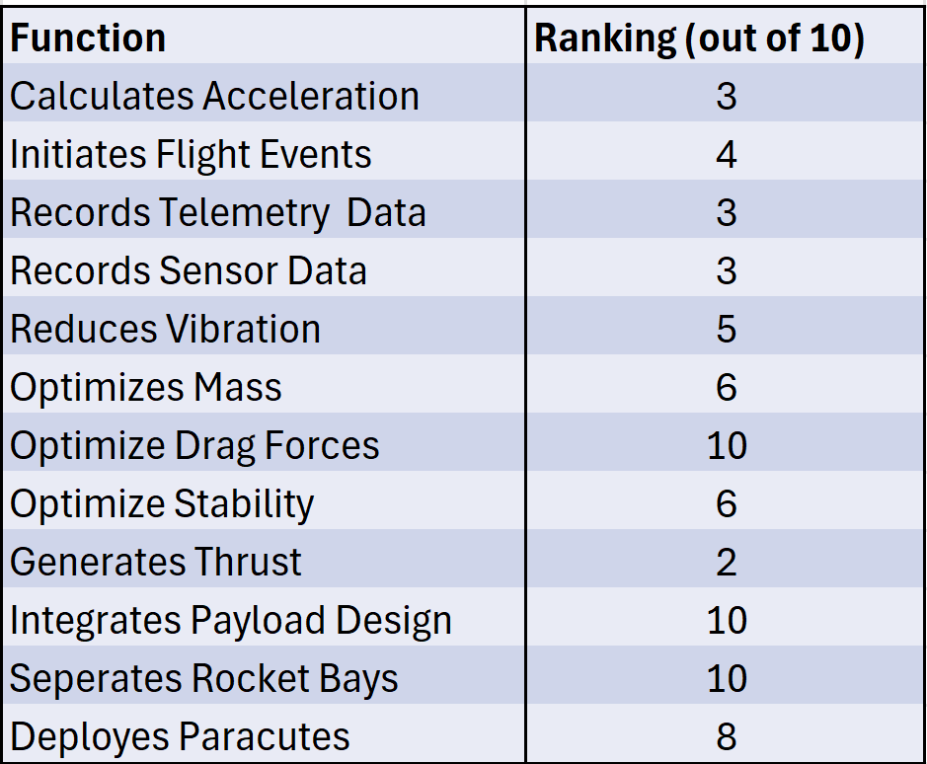

Table: Rocket Smart Integration Potential

**Action and Outcome**

At the basics, our rocket vehicle must burn a solid rocket motor while maintaining its stability and then coast to our designed apogee. The avionics subsystem will then initiate the drogue parachute which brings the vehicle into a controlled rapid descent to the main separation stage where the larger parachute will slow the vehicle to a human-survivable landing speed.

The airframe subsystem is responsible for propelling the vehicle to the apogee. The expected outcome of propulsion is the generation of internal and external pressures that differ significantly from its inert state, pressures produce lift along the fins which effect stability performance and can result in fin flutter which is the oscillation of critical airframe components. Material vibration during flight is also a concern. Our design must address these challenges with propulsion and other components of the airframe subsystem.

The avionics subsystem needs to record flight data and work with the recovery subsystem to ensure that the parachutes deploy at the proper altitude. The recovery must also meet NASA Student Launch Handbook STEMnauts guidelines. Wireless-capable onboard computers transmit to ground. However, due to the proximity to the separation charges and the payload system we must address the resulting electromagnetic impacts on other electronics hardware. The avionics subsystem will use shielding materials to prevent interference with other devices.

The avionics subsystem also holds authority over parachute packing and the deployment sequence. Our rocket vehicle must be assembled and then moved to the launch location. Movement over uneven terrain has been known to result in parachute deployment issues since the cords are prone to tangling. The separation team must pack the parachutes correctly to prevent deployment issues. They must also select the appropriate parachutes to ensure that the descent follows required parameters.